**Frontend Development with React.js**

**Project Documentation format**

1. **Introduction**
   * **Project Title**: Rhythmic Tunes
   * **Team Members** **and Roles:**
   * **Team Leader:** Vinitha M
   * **Team Members:**
     + Umamakeshwari V
     + Swetha V
     + Thilagavathi B
2. **Project Overview**

**Purpose**:

A Rhythmic music streaming app primarily serves the purpose of providing users with a platform to listen to music that is synchronized with rhythms and beats. And with a curated selection of music designed to enhance the experience of rhythmic activities such as dancing, exercising, or studying.

**Features**:

**Key features and functionality:**

* **Song listings:** Display a comprehensive list of available songs with details such as title, artist, genre and release date.
* **Playlist Creation:** Empower users to create personalized playlists, adding and organizing songs based on their preferences.
* **Playback Control:** Implement seamless playback control features, following users to play, pause, skip and adjust volume during music playback.
* **Search Functionality:** Implement a robust search feature for users to easily find specific songs, artists, or albums within the app.

1. **Architecture**

**Component Structure**:

* **Home Screen:** Display personalized recommendation, featured playlists, and access to activity-based music.
* **Search/Explore:** A search bar and filter option to follow users to explore content based on genre, mood, tempo, or activity type.
* **Playlist Management:** Allows users to create, save, share and edit playlist.
* **Profile Screen:** display user’s preferences, past activity data, saved songs, and playlist.
* **Social Sharing:** Enables users to share songs, playlist, or activities with friends.

**State Management:**

Local State uses Managed within a single component.

**Routing**:

React.js for a dynamic user interface. We also integrated React Router Dom for seamless navigation.

1. **Setup Instructions**

**Prerequisites**:

* Node.js and npm
* React.js
* Git for version control
* Code editor (e.g., visual studio code, sublime text, or webstorm)

**Installation**:

* Clone the repository:

Git clone [repository-link]

* Navigate to the project directory:

Cd project-name

* Install dependencies:

Npm install

* Start the development server:

Npm run dev

* Start the JSON server:

Json-server—watch ./db/db.json

1. **Folder Structure**

Rhythmic-Tunes/  
│── src/  
│ ├── assets/   
│ ├── components/   
│── public/

│ ├──songs/  
│── package. json  
│── README.md

1. **Running the Application**

**Run the frontend server:**

npm start

Access the app at http://localhost:5173

1. **Component Documentation**

* Play, pause, skip tracks
* Display track info (title, artist, album cover)
* Handle progress bar and seek functionality
* Adjust volume

1. **State Management**

* **Local State**-Managed within a single component (e.g., React’s use state)

1. **User Interface**

Screenshots:

* **Playlist**

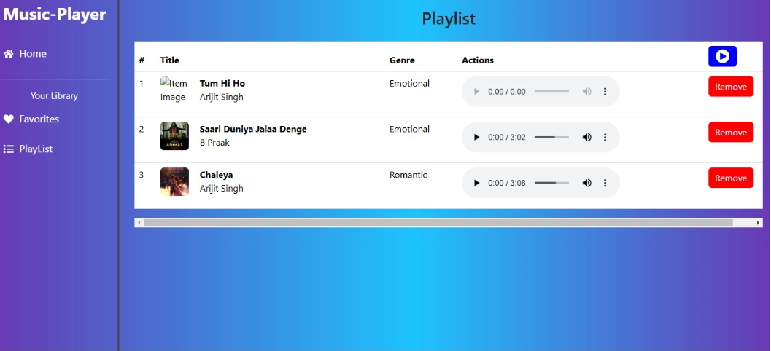

10.**Styling**

* Bootstrap/tailwind CSS for sleek design.
* Axios for efficient API communication.

1. **Testing**

* Jest & React Testing used for unit and integration testing.

1. **Screenshots or Demo**

* **Favorites**

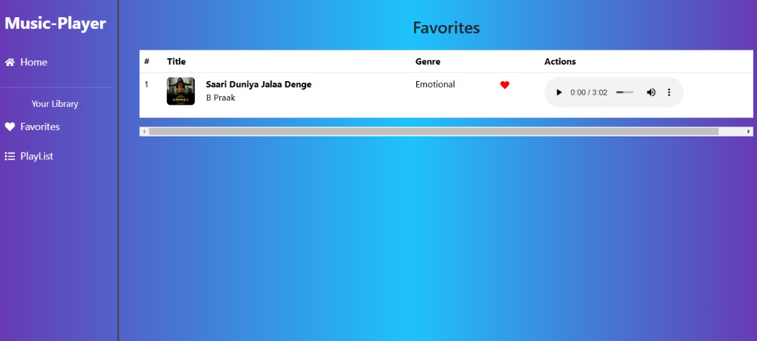

13. **Known Issues**

* The play/pause button does not update.
* The UI becomes unresponsive when switching tracks.

1. **Future Enhancements**

* Use collaborative filtering (like Spotify) to suggest music based on similar users’ behavior.
* Allow users to say ‘Play some relaxing music” and generate a playlist dynamically.

1. Code repository:

Source Code

<https://drive.google.com/drive/folders/1boIbT2wQiih_w7YrvwQRUr1fGXzLJH0O>

GitHub Link :

<https://github.com/vinitha1024/Rythimic-tunes>

Demo Link:

<https://drive.google.com/file/d/1QDBD-Cf9rXOI2dPWBAeWoCsEKvfge22s/view?usp=sharing>